1. **Event Plan**

1. Event Overview

Event Name: RegionLink EXPO (Seasons 2 & 3)

Organizer: Regional Web3 Cooperation Association (RWCA)

Purpose:

Connect local governments, students, businesses, and Web3 stakeholders to

to create co-creation projects rooted in regional challenges

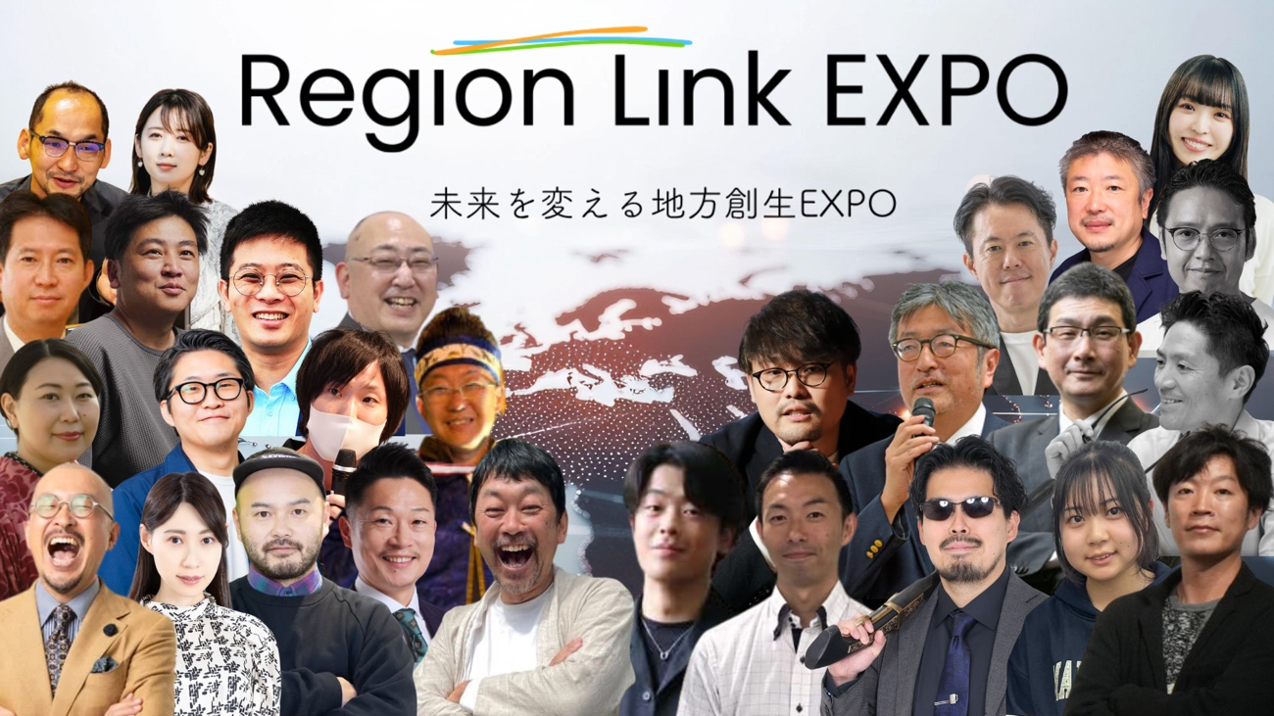

ダイアグラム が含まれている画像

AI 生成コンテンツは誤りを含む可能性があります。

2. Venue Reservation & Implementation Overview

Main Venue

November 2, 2025: Osaka Venue, Ritsumeikan University

<https://www.ritsumei.ac.jp/campusmap/>

November 29, 2025: Tokyo Venue - Minato City Industrial Promotion Center

<https://minato-sansin.com/>

Main Hall (Panel Discussions & Pitches)

EXPO Exhibition Area

Networking Space

グラフ

AI 生成コンテンツは誤りを含む可能性があります。

建物, テーブル, 木製, 座る が含まれている画像

AI 生成コンテンツは誤りを含む可能性があります。

3. Program Timeline

Program Timeline (Osaka Venue: Ritsumeikan University)

Venue Overview

Venue: Ritsumeikan University Osaka Ibaraki Campus (Osaka)

Format: Offline event + partial online streaming

Hours: 9:00 AM - 5:05 PM

Structure:

Regional Presentations / Sponsor Sessions /

Business Contest / Panel Discussion

**🎥 REGIONLINK #003 EXPO in Osaka｜Main Venue LIVE Archive**

📺 <https://youtube.com/live/C2ePmJyzEHw>

**🎥 REGIONLINK #003 EXPO in Osaka｜Live Stream Archive**

📺 <https://youtube.com/live/_yXXQA4iWzY>

**🎥 REGIONLINK #002 Business Idea Contest 2025 Preliminary Round LIVE Archive**

📺 <https://youtube.com/live/-WJERn_nSZo>

[Morning Program] Regional/Municipal Presentations

| Time | Content |

| | |

| 09:00 | Doors Open / Registration Starts |

| 09:05 | Initial Announcements |

| 09:10 | MC/Broadcast Preparation |

| 09:15 | Opening Ceremony |

| 09:20 | Judges and Company Introductions |

| 09:25 | RegionLink Overview |

| 09:30 | Exhibits and Exhibitor Introductions |

| 09:40 | Hokkaido Area Introduction |

| 10:00 | Hannan City (Osaka Prefecture) |

| 10:05 | Hyogo Prefecture - Tajima Region |

| 10:10 | Hyogo Prefecture, Sumoto City |

| 10:15 | Nara Prefecture, Uda City |

| 10:20 | Regional Key Person Announcement |

| 11:00 | Miyako Town, Fukuoka Prefecture |

| 11:05 | Kamiishi Highlands Town, Hiroshima Prefecture |

| 11:10 | Yoshino City, Tokushima Prefecture |

| 11:15 | Mihara Village, Kochi Prefecture |

| 11:30 | Niigata Prefecture & Corporate Collaboration Session |

| 11:40 | Sponsor Presentation |

| 12:00 | Hachinohe City / Joetsu City / Setouchi City |

| 12:15 | Minamisōma City (Video) |

| 12:30 | Lunch Break |

During the morning session, municipalities and regions from across Japan took the stage consecutively,

sharing diverse regional challenges and case studies on tourism, industry, population decline, DX, education, and more.

The short, high-density format was designed to allow participants to gain cross-regional understanding.

[Afternoon Program] International/Sponsor/Panel Sessions

| Time | Content |

| | |

| 13:00 | Monzen Town, Ishikawa Prefecture |

| 13:05 | Kanazawa City |

| 1:10 PM | Shimoda/Minamiizu |

| 1:15 PM | Komatsu City |

| 1:30 PM | Overseas Region Introduction (Kigali) |

| 1:35 PM | France, Paris |

| 1:45 PM | Philippines |

| 2:00 PM | Startup Pitch |

| 2:30 PM | RegionLink Lecture |

| 3:00 PM | Panel Discussion ① "Co-creation Driven by the Next Generation" |

| 3:35 PM | Panel Discussion 2: "The Co-Creation Economy and Organizations" |

| 4:20 PM | Panel Discussion 3: "From Local to Global" |

| 4:55 PM | Startup Presentation |

| 17:05 | Closing |

The afternoon session focused on regional case studies from Japan and abroad, private sector players, and discussion-based panels,

delving into regional challenges from the perspectives of "Implementation, Co-creation, and International Expansion."

A key feature was the design enabling multi-layered stakeholders to debate within the same space.

Program Timeline (Tokyo Venue: Minato City Industrial Promotion Center)

Venue Overview

Venue: Minato City Industrial Promotion Center (Tokyo)

Format: Offline + Partial Online Streaming

Hours: 10:30 AM - 6:02 PM

Program Structure:

Keynote Speech / Municipal Government Presentations / Workshops /

Sponsor Pitch / Business Contest Finals / Panel

[Morning Program] Opening & Local Government Presentations

| Time | Content |

| | |

| 10:30 | Doors Open |

| 11:00 | OPENING |

| 11:08 | Keynote Address |

| 11:28 | Local Government Presentation Session |

| 11:34 | Saga Prefecture |

| 11:40 | Shigaraki Town, Koka City, Shiga Prefecture |

| 11:46 | Tomamae Town, Hokkaido |

| 11:52 | Hokkaido, Otobe Town |

| 11:58 | Okinawa Prefecture, Chatan Town |

| 12:04 | Gotemba City, Shizuoka Prefecture |

| 12:10 | Kotohira Town, Kagawa Prefecture |

| 12:16 | Miyagi Prefecture, Sendai City |

| 12:22 | Anpachi Town, Gifu Prefecture |

| 12:28 | Iida City, Nagano Prefecture |

| 12:34 | Kumamoto City, Kumamoto Prefecture |

| 12:40 | Uccie, Poland |

| 12:46 | Lunch Break (Partially Broadcast) |

Ten domestic municipalities and one overseas municipality participated,

presenting initiatives on regional revitalization, tourism, industry, human resources, and DX.

The format, including international case studies, provided participants with a broad perspective.

[Early Afternoon] Workshops & Sponsor Sessions

| Time | Content |

| | |

| 13:05 | Workshop |

| 14:00 | Sponsor Pitch |

| 14:06 | Eight Engineering |

| 14:12 | TIS Corporation |

| 14:18 | Butterfly Base |

| 14:24 | KATARiBA |

Building on the morning's municipal presentations,

participatory workshops and sharing of implementation perspectives by companies were conducted.

This served as a time to connect regional challenges to concrete actions.

[Afternoon Session] Business Contest Finals & Panel

| Time | Content |

| | |

| 14:30 | Business Contest Finals Begin |

| 14:32 | Final Round 1 |

| 14:47 | Final Match 2 |

| 15:02 | Final Round 3 |

| 15:17 | Final Match 4 |

| 15:32 | Final 5 |

| 15:47 | Final Match 6 |

| 16:02 | Panel Discussion 1 |

| 16:32 | Panel Discussion 2 |

| 17:02 | Panel Discussion 3 |

| 17:32 | Panel Discussion 4 |

| 18:02 | Closing |

The business contest featured practical business proposals rooted in regional challenges.

The subsequent panel discussion featured representatives from local governments, businesses, education, and practitioners,

discussed the future vision of co-creative regional revitalization.

Actual timetable image

List of Speakers

テーブル

AI 生成コンテンツは誤りを含む可能性があります。

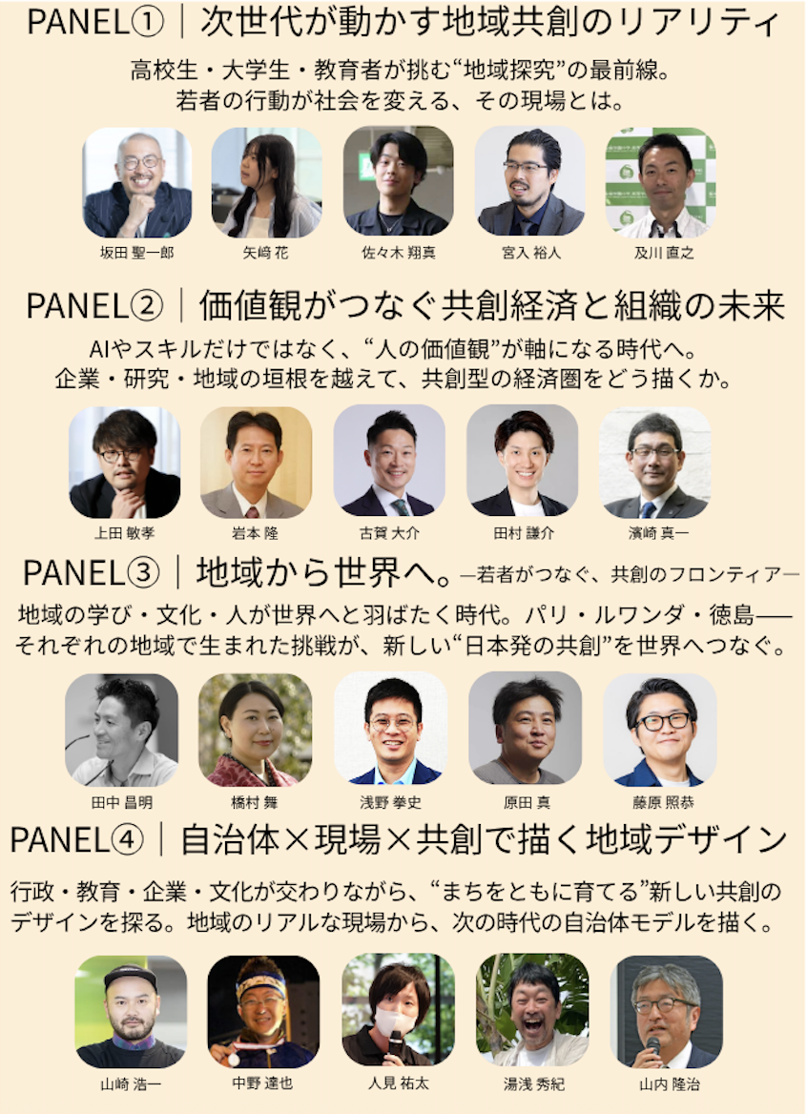

グラフィカル ユーザー インターフェイス

AI 生成コンテンツは誤りを含む可能性があります。

タイムライン

AI 生成コンテンツは誤りを含む可能性があります。

グラフィカル ユーザー インターフェイス

AI 生成コンテンツは誤りを含む可能性があります。

タイムライン が含まれている画像

AI 生成コンテンツは誤りを含む可能性があります。

4. Operational Structure

Overall Coordination: RWCA Operations Team

Registration & Facilitation: Staff / Student Volunteers

Recording: Photo and Video Team